### Project Name: Job Application Tracking System - (Developer)

### Team ID : LTVIP2024TMID11609

### Team Leader : S MOHAN

### Team member : N KARTHIK

### Role

**Creation Of Role**

1.From the Quick find box search for the role and click on the roles option  
2.select the set up roles option

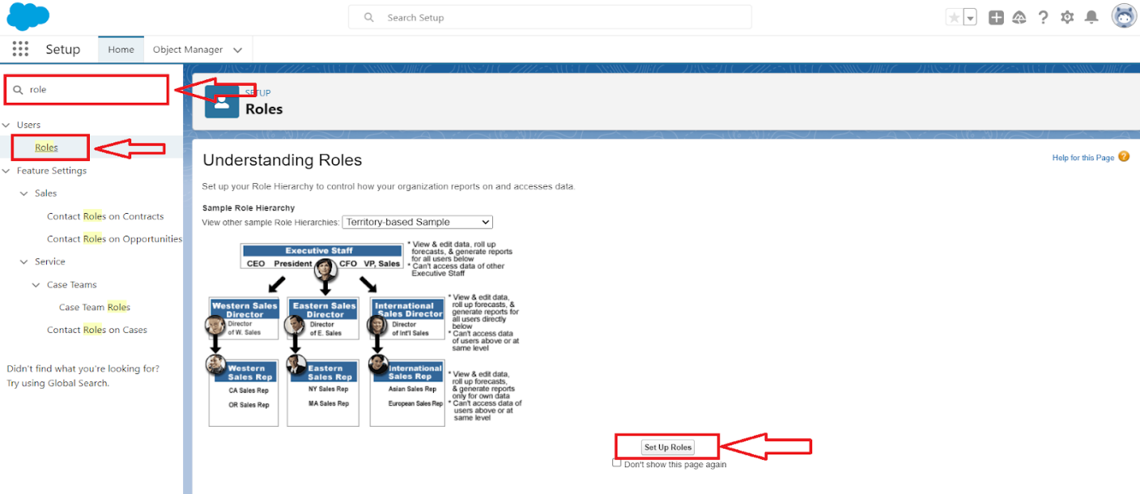

3.Below the CEO click on add role and enter the label name as a ” HR Manager ” and role name will be Automatically populated and click on save.  
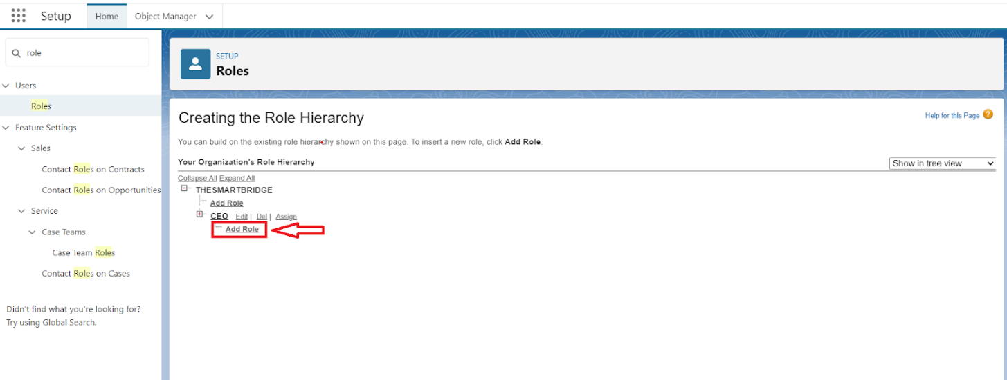  
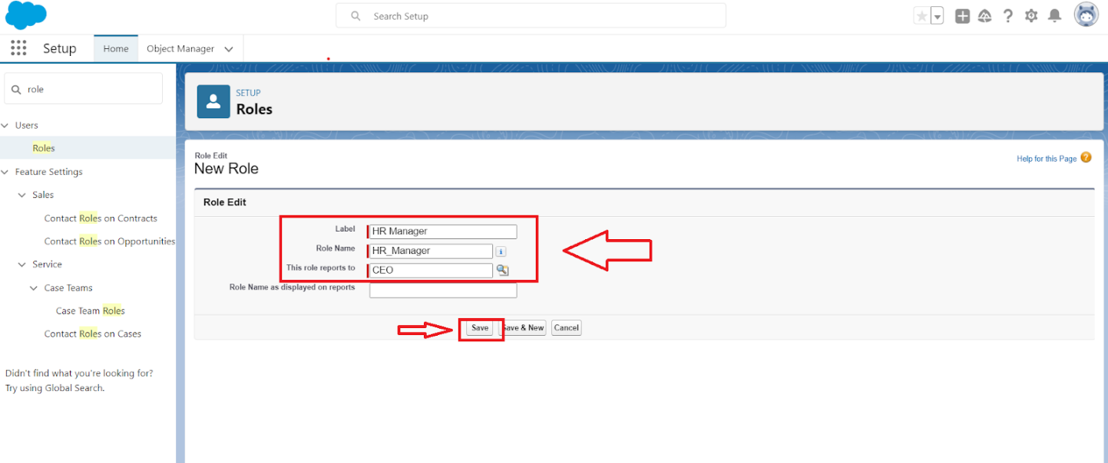

### User

**To Create A User**

1.From Setup, enter Users in the Quick Find box, then select Users.  
2.Click New User.  
  
  
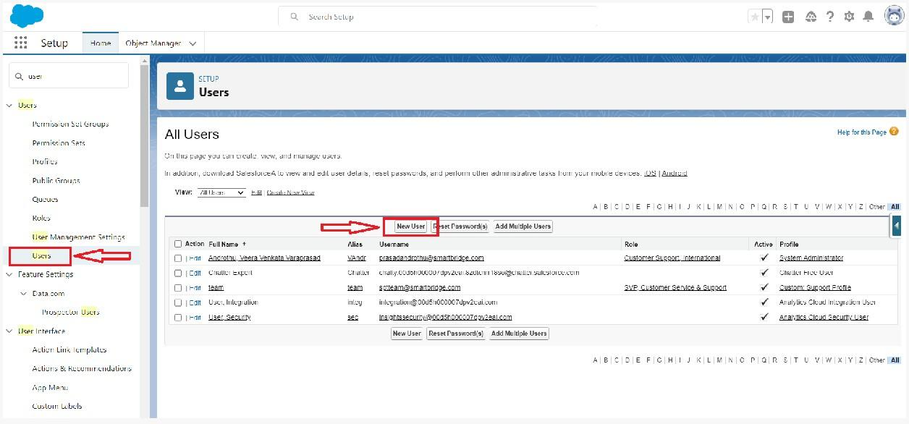  
3.Enter First name as HR and last name as Manager.  
4.Enter the user’s name and email address and a unique username in the form of an email address. By default, the username is the same as the email address.  
  
5.Then create a new role HR Manager.  
6.Select user License as Standard Platform User.  
7.Select profile(Recruiter).  
  
  
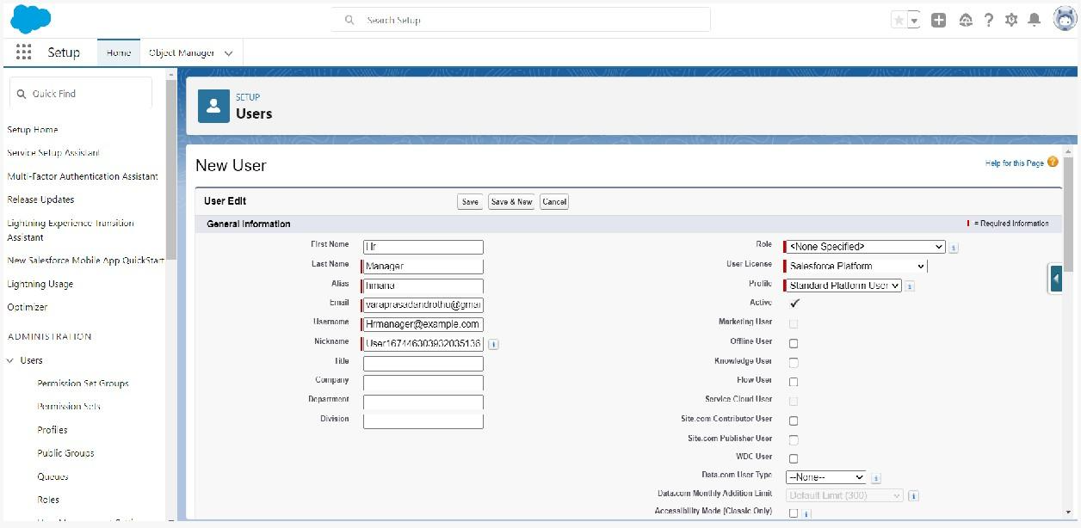  
8.Click save

**Create Another User**

Create a user with a username as “Ganesh Gelli”, and assign him the sales Manager profile. Follow the steps from above Activity

### Sharing Rules

**Create A Sharing Rule**

1.Go to Sharing Settings, which can be found under the Quick Find section.  
2.Scroll down and find the candidate object where a sharing rule needs to be added, and then click on New to create a new sharing rule.  
  
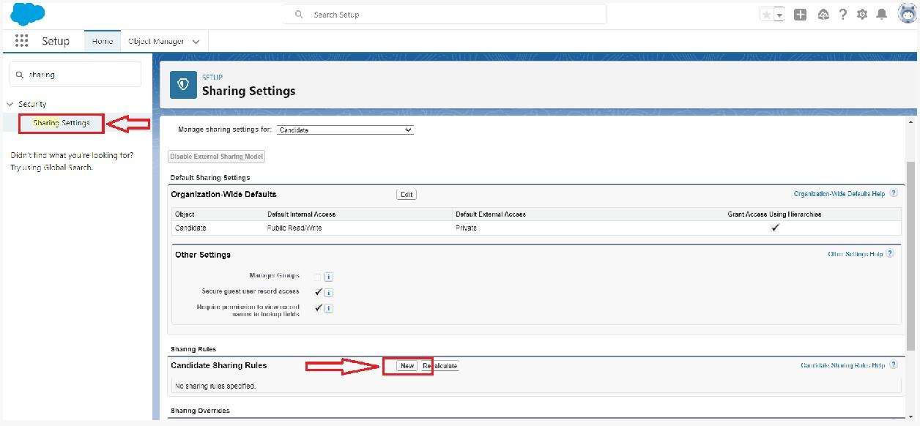  
  
3.Add the label of the sharing rule you want to make.  
4.Select your rule type based on the criteria.  
5.Select the field can join immediately check field from the candidate object.  
6.Select the State as equal and value is Rajasthan.  
7.And in selecting the users to share with the section select roles and in that select Hr Manager.  
8.And in the section of select the level of access for the users give the access Read/Write.

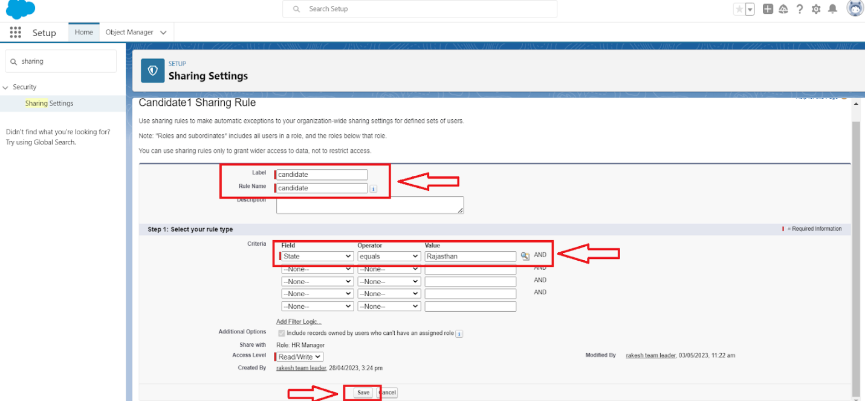  
  
9.And save the rule.

**Another Sharing Rule**

Create a Sharing Rule to Share the records of Job Application to Hr Manager with the Access of Read/Write.  
Follow the steps from above Activity.